Navrachana University Vadodara

School: School of Business and Law
Program: BBA, MBA
Title of the Event: Start-up Talk :Valuation of Start-ups
Date: 07.03.2023

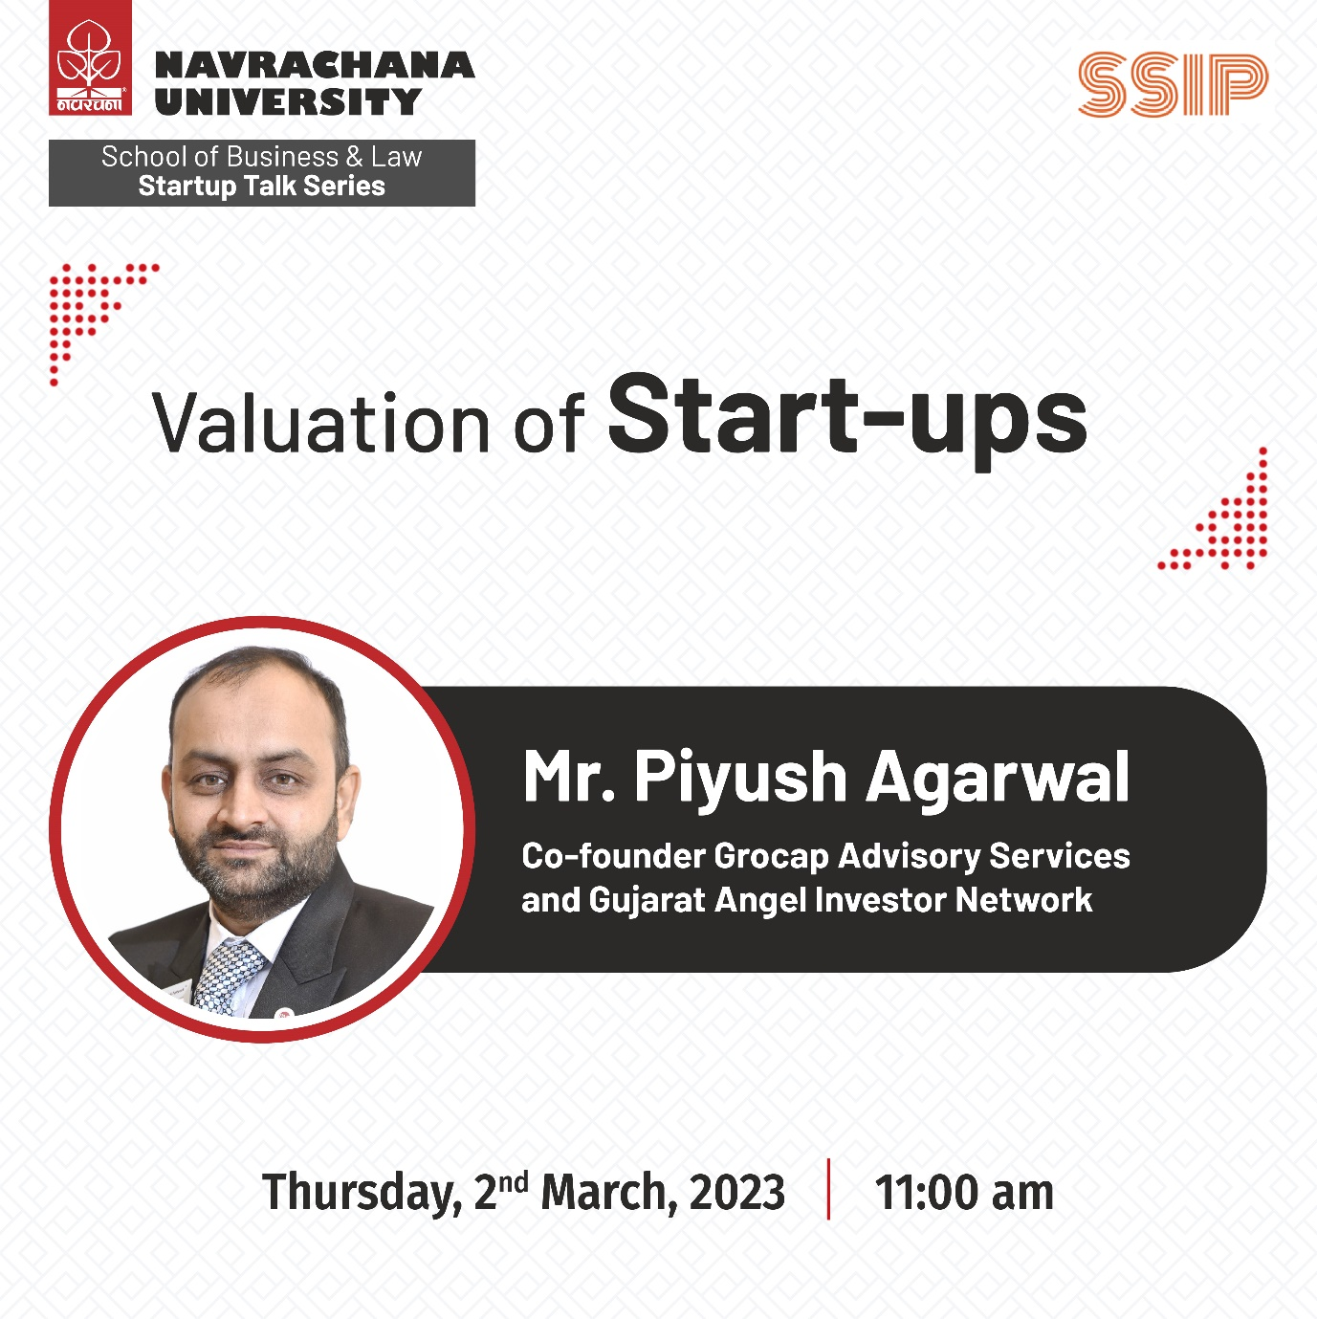

Summary Report of the Activity/Event Conducted

Category: (Seminar/Webinar/Symposium/  Training Program/Conference/ Activity/Event etc.) | Event
Name of Activity: | Start-up Talk :Valuation of Start-ups
Name of the agencies/consultants involved with contact details (if any)
Event organized for:  (NUV Faculty/NUV Students/NUV administration staff/Outside/All) | NUV students
Organising unit/ agency/ collaborating agency: | School of Business and Law, Navrachana University
Name of the Scheme | NA
Year of Activity | 2023
Mode of Program:  Online/Offline | Offline and online
Venue: | University Auditorium
Dignitary/s present at the function: | No | Name | Designation | Email | Phone
 | 1. | Piyush Agarwal | Co-Founder-GroCap Advisory Services | piyush@grocap.co.in | +91-9574130009
Total no. of participants | 166
Fees per participant If any  (External/Internal) | NA
Total Fees received If any | NA
Income from Other Sources If any | NA
Total Income | NA
Total expenditure if any | NA
Brief Summary of the event:

Mr. Piyush Agarwal is an experienced investment banker, entrepreneur and startup enthusiast with work experience in consulting (business, advisory, valuation) and passion for finance. He has a record of closing over 25 fund-raising transactions. Created a startup investment community in Baroda and mentored/advised more than 10 startups and connected them with angels/seed, HNI / family offices and VC firms.
He is co-founder of Grocap Advisory Services, where he assists SMEs and startups in the growth/expansion journey by helping them raise funds via debt and/or equity. He is also cofounder at GAIN (Gujarat Angel Investor Network) .
The session was organized for second year BBA students undertaking a course on Business Planning but was open for other students of the university as well. Mr. Piyush Agatwal first discussed the concept and eligibility of start-up with the students. Later he oriented the students about different methods of Valuation including Discounted Cash Flow, Market and Transaction Comparable, Asset Valuation Method and The Venture Capital Method. He also discussed the important criteria considered by investors before funding a start-up and the relative importance allocated to each of the criteria by the investor.
The students’ questions regarding valuation of start-ups were mailed to the students in advance, the speaker addressed those questions as well as other questions asked by the students on the spot during the session.
Photographs of the event:
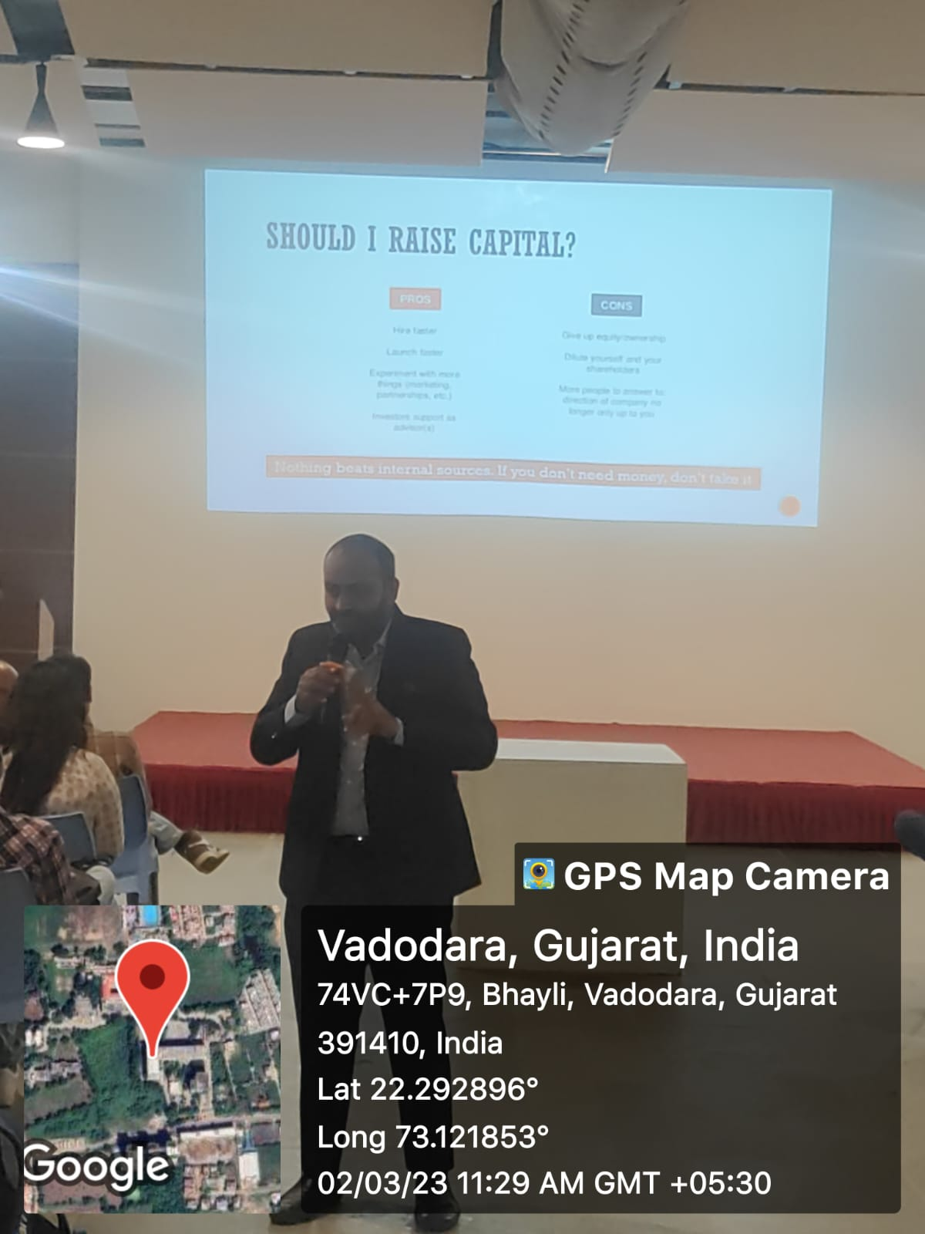

Mr. Piyush Agarwal addressing student questions related to Startup Valuation
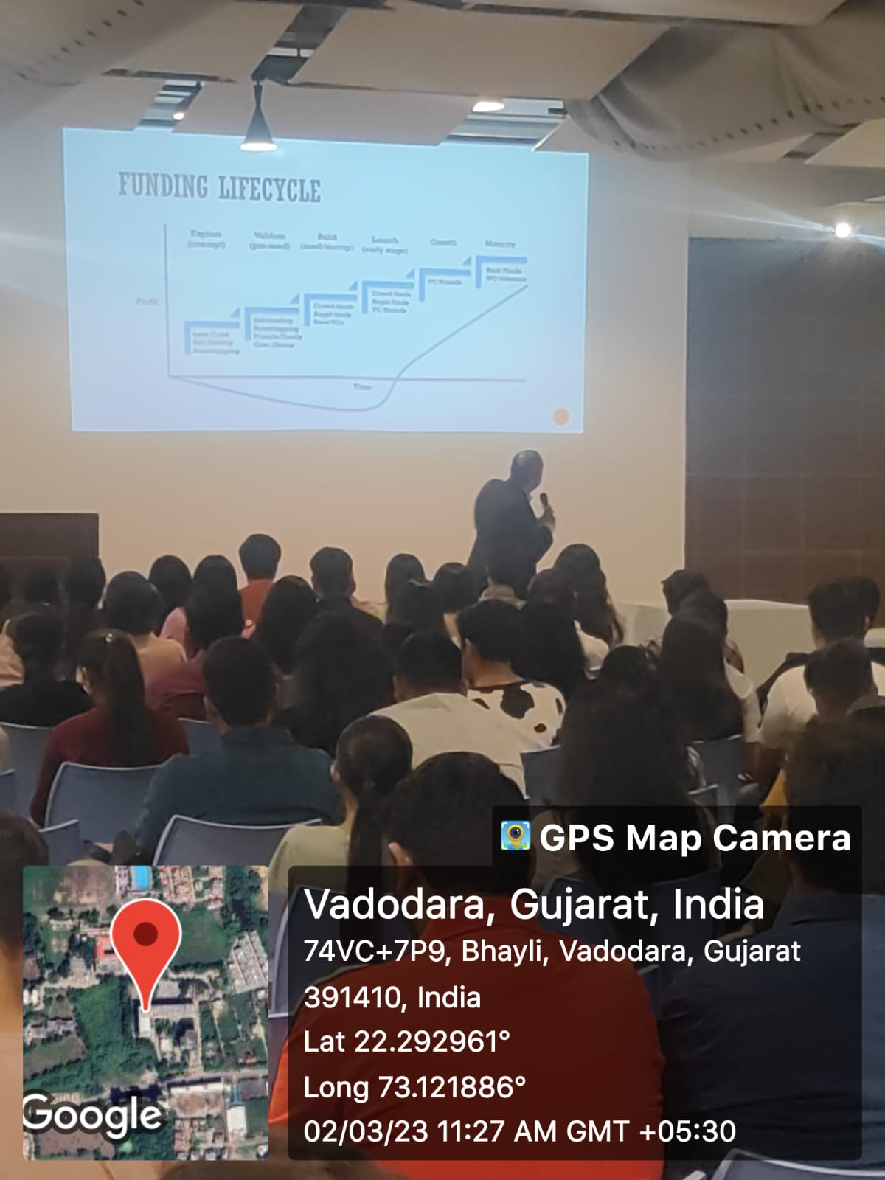
Mr. Piyush Agarwal talking about stages of Start-up
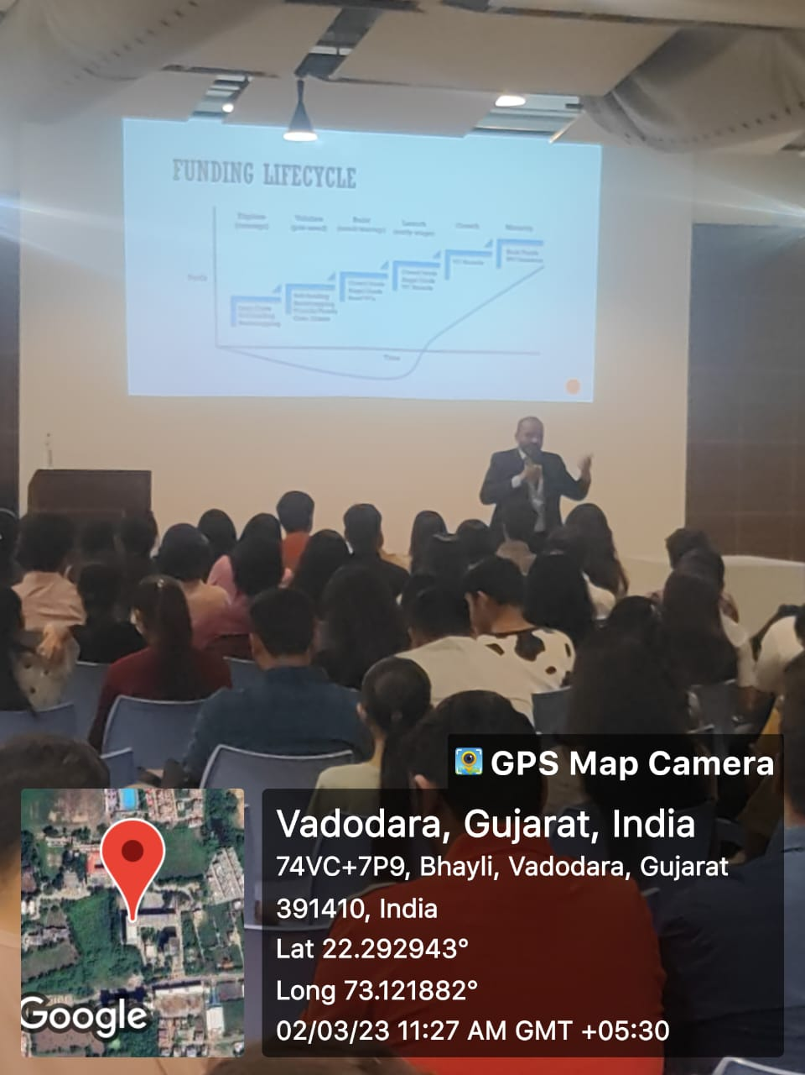
Mr. Piyush Agarwal talking about different methods of valuation

Participants List-

Sr. No. | Name | Organization | Type  (Faculty/Student/ Industry etc..) | Email Id
1 | Aadil Patel | NUV | Student | 21131117@nuv.ac.in
2 | Aayush Raj | NUV | Student | 21131194@nuv.ac.in
3 | Abhinav Saravta | NUV | Student | 21131110@nuv.ac.in
4 | Dhruv Tushar Shah | NUV | Student | 21131212@nuv.ac.in
5 | DivyarajSinh Rajendrasinh Jadeja | NUV | Student | 21131210@nuv.ac.in
6 | Fardeen Maysar Hussain Pathan | NUV | Student | 21131113@nuv.ac.in
7 | Hiral Paresh Bhatt | NUV | Student | 21131193@nuv.ac.in
8 | Jenish Vipulbhai Lakkad | NUV | Student | 21131182@nuv.ac.in
9 | Meet Tejpal Gurnani | NUV | Student | 21131195@nuv.ac.in
10 | Mohammed Obaid Aslam Ali Saiyed | NUV | Student | 21131115@nuv.ac.in
11 | Palak Shah | NUV | Student | 21131060@nuv.ac.in
12 | Prachi Parikh | NUV | Student | 21131063@nuv.ac.in
13 | Pranali Paresh Thakkar | NUV | Student | 21131064@nuv.ac.in
14 | Pranami Vyas | NUV | Student | 21131065@nuv.ac.in
15 | Pratvi Patel | NUV | Student | 21131066@nuv.ac.in
16 | Preet Mitul Shah | NUV | Student | 21131211@nuv.ac.in
17 | Preksha Shah | NUV | Student | 21131067@nuv.ac.in
18 | Rajdeep Jagtap | NUV | Student | 21131108@nuv.ac.in
19 | Ratan Sharma | NUV | Student | 21131071@nuv.ac.in
20 | Ravi Patel | NUV | Student | 21131072@nuv.ac.in
21 | RITIKA YATIN KUMAR SHAH | NUV | Student | 21131184@nuv.ac.in
22 | Rudra Padaria | NUV | Student | 21131073@nuv.ac.in
23 | Rutvi Patel | NUV | Student | 21131074@nuv.ac.in
24 | Sharan Nair | NUV | Student | 21131077@nuv.ac.in
25 | Shreyans Pandya | NUV | Student | 21131114@nuv.ac.in
26 | Shubham Samir Shah | NUV | Student | 21131079@nuv.ac.in
27 | Siddharth Nitesh Khatlawala | NUV | Student | 21131080@nuv.ac.in
28 | Siddhi Patel | NUV | Student | 21131081@nuv.ac.in
29 | Sidharth Girishkumar . | NUV | Student | 21131111@nuv.ac.in
30 | Siya Vinay Baraiya | NUV | Student | 21131209@nuv.ac.in
31 | SMIT HEMANG ASHER | NUV | Student | 21131213@nuv.ac.in
32 | SOHAIL ANISH KHAN | NUV | Student | 21131183@nuv.ac.in
33 | Styrish Srinivasan | NUV | Student | 21131083@nuv.ac.in
34 | Subin David | NUV | Student | 21131084@nuv.ac.in
35 | Sujan Shakur Minivadia | NUV | Student | 21131085@nuv.ac.in
36 | Sumeet Kewlani | NUV | Student | 21131086@nuv.ac.in
37 | Sunil Suthar | NUV | Student | 21131087@nuv.ac.in
38 | Sweety Hitendra Patel | NUV | Student | 21131119@nuv.ac.in
39 | TATVA RIPAL DESAI | NUV | Student | 21131187@nuv.ac.in
40 | Ujwal Mehta | NUV | Student | 21131089@nuv.ac.in
41 | Urja Sutaria | NUV | Student | 21131090@nuv.ac.in
42 | Urvangi Soni | NUV | Student | 21131091@nuv.ac.in
43 | Vaibhav Thakkar | NUV | Student | 21131092@nuv.ac.in
44 | VAISHNAVI JAYAJI SHINDE | NUV | Student | 21131180@nuv.ac.in
45 | Vansh Prakashbhai Kewlani | NUV | Student | 21131093@nuv.ac.in
46 | Varish Bhatt | NUV | Student | 21131094@nuv.ac.in
47 | Varmit Koradia | NUV | Student | 21131095@nuv.ac.in
48 | Ved Patel | NUV | Student | 21131096@nuv.ac.in
49 | Vedant Patel | NUV | Student | 21131097@nuv.ac.in
50 | YASH JAYESH PATEL | NUV | Student | 21131181@nuv.ac.in
51 | Yash Shah | NUV | Student | 21131102@nuv.ac.in
52 | Yash Solanki | NUV | Student | 21131103@nuv.ac.in
53 | Yashika Grover | NUV | Student | 21131105@nuv.ac.in
54 | YOGI JAYESH PATEL | NUV | Student | 21131106@nuv.ac.in
55 | Adi Imtiaz Vohra | NUV | Student | 21131120@nuv.ac.in
56 | Adithya Kishor Varu | NUV | Student | 21131137@nuv.ac.in
57 | Ansh | NUV | Student | 21131203@nuv.ac.in
58 | Apoorva Manoj Kumar Anand | NUV | Student | 21131152@nuv.ac.in
59 | Aryan Alpesh Parmar | NUV | Student | 21131124@nuv.ac.in
60 | Ashna Benny | NUV | Student | 21131171@nuv.ac.in
61 | ASHVINI SAMIRKUMAR PATEL | NUV | Student | 21131161@nuv.ac.in
62 | Austin Kelsey Mathew | NUV | Student | 21131142@nuv.ac.in
63 | Azim Ayazkhan Talukdar | NUV | Student | 21131160@nuv.ac.in
64 | Bansi Shaileshbhai Vaiyata | NUV | Student | 21131149@nuv.ac.in
65 | Bhavya | NUV | Student | @nuv.ac.in
66 | Daaman Jaideepsinh Raulji | NUV | Student | 21131126@nuv.ac.in
67 | Deesha Vicky Jain | NUV | Student | 21131175@nuv.ac.in
68 | Divyarajsinh Janaksinh Rana | NUV | Student | 21131164@nuv.ac.in
69 | Dutt Darshan Bhavsar | NUV | Student | 21131118@nuv.ac.in
70 | Gaurav Sanjay Rai | NUV | Student | 21131177@nuv.ac.in
71 | Harsh Shashin Pancholi | NUV | Student | 21131179@nuv.ac.in
72 | Hetvi Jitendra Mandge | NUV | Student | 21131144@nuv.ac.in
73 | Himani Kiran Patel | NUV | Student | 21131172@nuv.ac.in
74 | Himanshu Singh | NUV | Student | 21131166@nuv.ac.in
75 | ISHA SAMIR RATHOD | NUV | Student | 21131206@nuv.ac.in
76 | Juvayriyah Imran Patni | NUV | Student | 21131132@nuv.ac.in
77 | Kavita Nimit Bhavsar | NUV | Student | 21131168@nuv.ac.in
78 | Khush Bhavesh Shah | NUV | Student | 21131141@nuv.ac.in
79 | Khushi Manish Taneja | NUV | Student | 21131146@nuv.ac.in
80 | Kishan Ashok Mistry | NUV | Student | 21131130@nuv.ac.in
81 | Krupali Mukeshsinh Thakor | NUV | Student | 21131134@nuv.ac.in
82 | Manav Dharmendrabhai Patel | NUV | Student | 21131139@nuv.ac.in
83 | Manav Vipulbhai Dholiya | NUV | Student | 21131167@nuv.ac.in
84 | Namrata Prakash Gagnani | NUV | Student | 21131122@nuv.ac.in
85 | Nandinee Singh | NUV | Student | 21131162@nuv.ac.in
86 | Om Mayur Kumar Patel | NUV | Student | 21131153@nuv.ac.in
87 | Palna Kalpesh Patel | NUV | Student | 21131150@nuv.ac.in
88 | Panth Bhaveshbhai Patel | NUV | Student | 21131156@nuv.ac.in
89 | Patel Khushiben Ashwin | NUV | Student | 21131157@nuv.ac.in
90 | Payal Dhanesh Mohinani | NUV | Student | 21131205@nuv.ac.in
91 | Pratham Dipak Rana | NUV | Student | 21131154@nuv.ac.in
92 | Pratham Kavindra Golchha | NUV | Student | 21131135@nuv.ac.in
93 | Pratham Sandip Vajifdar | NUV | Student | 21131133@nuv.ac.in
94 | Prince Ashokbhai Patel | NUV | Student | 21131178@nuv.ac.in
95 | Priyanshu Bharatbhai Chauhan | NUV | Student | 21131147@nuv.ac.in
96 | Rinky Yadav | NUV | Student | 21131148@nuv.ac.in
97 | Rucha Soni | NUV | Student | 21131204@nuv.ac.in
98 | Rushi Pragneshkumar Patel | NUV | Student | 21131143@nuv.ac.in
99 | Sakshi Bhavik Purohit | NUV | Student | 21131159@nuv.ac.in
100 | Sandhya Ganeshkumar Gohil | NUV | Student | 21131121@nuv.ac.in
101 | Shweta Sanjaybhai Sardesai | NUV | Student | 21131138@nuv.ac.in
102 | Siddharth Sachin Deshpande | NUV | Student | 21131131@nuv.ac.in
103 | Smruti Amit Mamtora | NUV | Student | 21131169@nuv.ac.in
104 | Suraj Sunil Pillai | NUV | Student | 21131151@nuv.ac.in
105 | Tina Jayeshbhai Patel | NUV | Student | 21131129@nuv.ac.in
106 | Utkarsh Mehta | NUV | Student | 21131140@nuv.ac.in
107 | VAIDIT NAVINBHAI PATEL | NUV | Student | 21131145@nuv.ac.in
108 | Vansh Brijesh Patel | NUV | Student | 21131174@nuv.ac.in
109 | YASHVI DINESH BHANSALI | NUV | Student | 21131186@nuv.ac.in
110 | Aayush Singh | NUV | Student | 21131001@nuv.ac.in
111 | Abhay Shah | NUV | Student | 21131002@nuv.ac.in
112 | Abhiraj Soni | NUV | Student | 21131003@nuv.ac.in
113 | Abhishek Patel | NUV | Student | 21131004@nuv.ac.in
114 | Abhishek Rajendra Padmashali | NUV | Student | 21131005@nuv.ac.in
115 | Afi Sait | NUV | Student | 21131008@nuv.ac.in
116 | Akshar Sachapara | NUV | Student | 21131009@nuv.ac.in
117 | Ameya Bhate | NUV | Student | 21131010@nuv.ac.in
118 | Ansh Agrawal | NUV | Student | 21131011@nuv.ac.in
119 | Anuj KUMAR Dutta | NUV | Student | 21131012@nuv.ac.in
120 | Arwa Muslim Vohra | NUV | Student | 21131014@nuv.ac.in
121 | Avin Jacob | NUV | Student | 21131015@nuv.ac.in
122 | Bhavik Patel | NUV | Student | 21131017@nuv.ac.in
123 | Deep Agrawal | NUV | Student | 21131018@nuv.ac.in
124 | Devansh Ray | NUV | Student | 21131019@nuv.ac.in
125 | Devanshi Modi | NUV | Student | 21131020@nuv.ac.in
126 | Dhruv Shaileshbhai Thakkar | NUV | Student | 21131022@nuv.ac.in
127 | Dhruvi Brahmbhatt | NUV | Student | 21131023@nuv.ac.in
128 | Elvish Hasnani | NUV | Student | 21131026@nuv.ac.in
129 | Gauri Nair | NUV | Student | 21131027@nuv.ac.in
130 | Harsh Soni | NUV | Student | 21131028@nuv.ac.in
131 | Harsh Patel | NUV | Student | 21131029@nuv.ac.in
132 | Harshkumar Patel | NUV | Student | 21131030@nuv.ac.in
133 | Heteshree Pathak | NUV | Student | 21131031@nuv.ac.in
134 | Hetvi Patel | NUV | Student | 21131032@nuv.ac.in
135 | Isha Amin | NUV | Student | 21131034@nuv.ac.in
136 | Jay Kalpesh Zaveri | NUV | Student | 21131035@nuv.ac.in
137 | Jeel Patel | NUV | Student | 21131037@nuv.ac.in
138 | Jimil Purohit | NUV | Student | 21131040@nuv.ac.in
139 | Kausthubh Magi | NUV | Student | 21131042@nuv.ac.in
140 | Khushi Patel | NUV | Student | 21131043@nuv.ac.in
141 | Krishna Goswami | NUV | Student | 21131044@nuv.ac.in
142 | Kush Patel | NUV | Student | 21131045@nuv.ac.in
143 | Madhur Kabara | NUV | Student | 21131048@nuv.ac.in
144 | Mahek Arora | NUV | Student | 21131049@nuv.ac.in
145 | Mahesh Purswani | NUV | Student | 21131050@nuv.ac.in
146 | Maitri Atul Patel | NUV | Student | 21131051@nuv.ac.in
147 | Maitry Miteshkumar Darji | NUV | Student | 21131052@nuv.ac.in
148 | Naitik Shah | NUV | Student | 21131055@nuv.ac.in
149 | Nishita Rakesh Mistry | NUV | Student | 21131057@nuv.ac.in
150 | Om Patwardhan | NUV | Student | 21131058@nuv.ac.in
151 | Pal Dhavalbhai Naik | NUV | Student | 21131059@nuv.ac.in
152 | Khushi Priteshkumar Patel | NUV | Student | 21131127@nuv.ac.in
153 | Satyam Jagdish Rohida |  |  | 21131188@nuv.ac.in
154 | Bakhtiyar Aiyub Khilji |  |  | 21131189@nuv.ac.in
155 | Mithil Taral Ghai |  |  | 21131190@nuv.ac.in
156 | Rushvi Devendrakumar Soni |  |  | 21131192@nuv.ac.in
157 | ZEBA FARID SAYED |  |  | 21131196@nuv.ac.in
158 | ANUSHKA VATSAL MACHCHHAR |  |  | 21131197@nuv.ac.in
159 | Khushi Mahendra Suthar |  |  | 21131198@nuv.ac.in
160 | Siddharth Jitendra Tailor |  |  | 21131199@nuv.ac.in
161 | Devanshi Satishbhai Patel |  |  | 21131200@nuv.ac.in
162 | Sonali Dharmesh Panwala |  |  | 21131201@nuv.ac.in
163 | Angad Prem Lohana |  |  | 21131202@nuv.ac.in
164 | Ayush Patel |  |  | 21131016@nuv.ac.in
165 | Nainpreetkaur Harjitsingh Ahluwalia |  |  | 21131054@nuv.ac.in
166 | Vyoma |  |  | 21131191@nuv.ac.in

Communication details with the speaker

Neha Taneja Chawla

To:
- piyush@grocap.co.in
Cc:
- Hitesh Bhatia
Wed 2/1/2023 11:03 AM
Dear Sir,

Thank you so much for agreeing to share your knowledge and experiences in the domain of start-up valuation with the students at School of Business and Law, Navrachana University. As discussed over the phone, we are scheduling it on Thursday,2nd March 2023 at 11 am. The duration of the session will be around one hour where you may initially talk to students about "Valuation of start-ups" followed by student interaction. As suggested, I will share the list of student questions with you in advance. As most of the students are curious about understanding valuation from the investor's perspective, your insights on this aspect will be very helpful.

Thanking you once again for agreeing to spare your valuable time for our students. Looking forward to your session.

Thanks & Regards

Neha Taneja Chawla
Assistant Professor
School of Business & Law

Vasna Bhayli Road | Vadodara 391410
Direct: 91-265-2617203 | Mobile: 9998403214 | Email: nehac@nuv.ac.in

